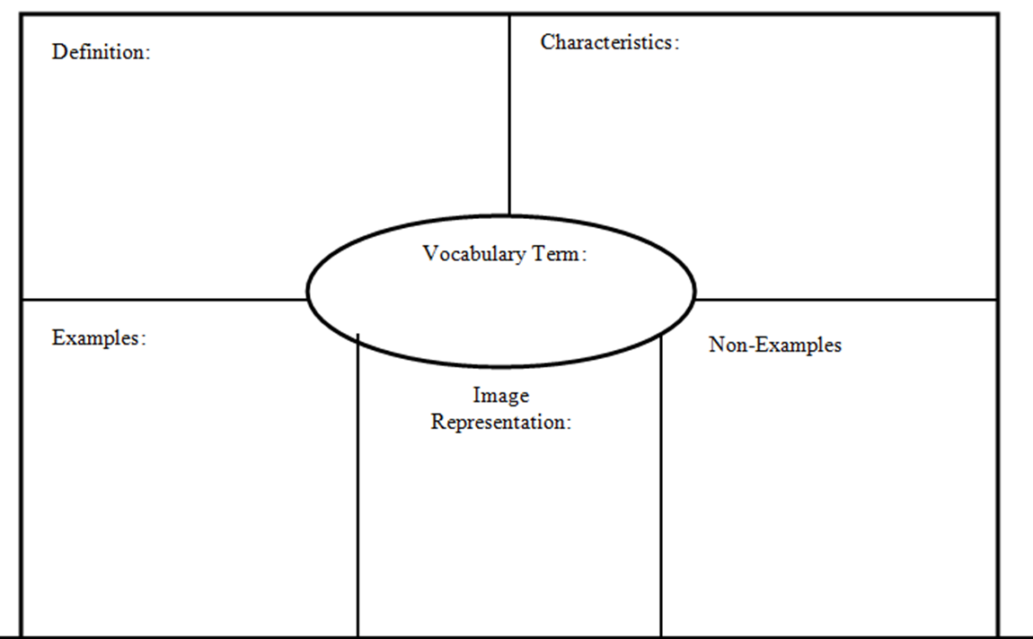

*List five examples of what the word is not or what it doesn’t mean (i.e. misconceptions)*

*List five examples of the word*

*List at five characteristics*