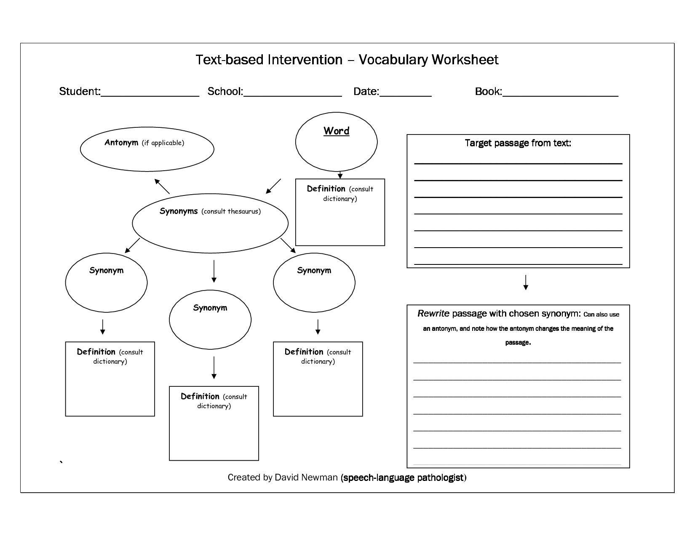

Copy the sentence from the book where the vocabulary word is used.

5 synonyms