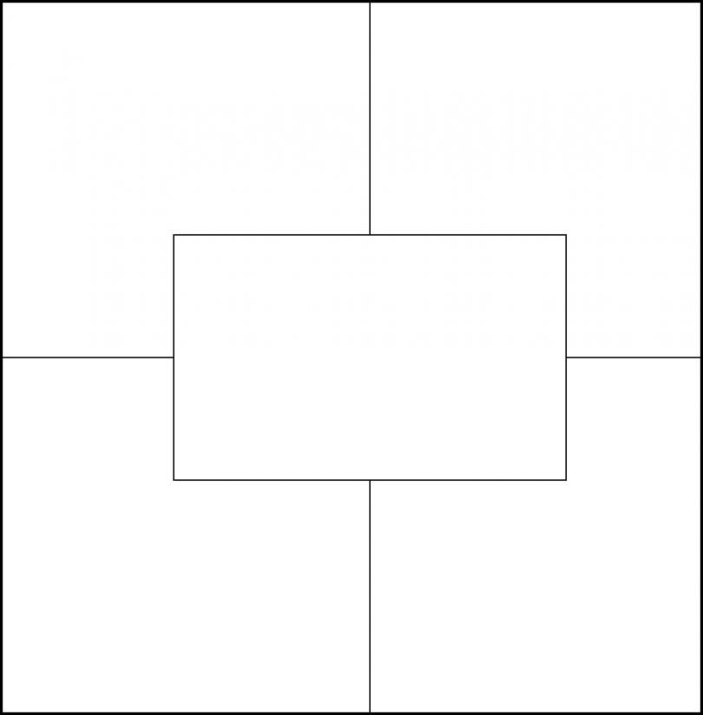

Inattention

Distracted

Confused

Lost

Not interested

(You can find these online)

[attention](http://www.merriam-webster.com/dictionary/attention), [concentration](http://www.merriam-webster.com/dictionary/concentration), [engrossment](http://www.merriam-webster.com/dictionary/engrossment), [enthrallment](http://www.merriam-webster.com/dictionary/enthrallment), [immersion](http://www.merriam-webster.com/dictionary/immersion)

1. I couldn’t return the phone call because I was absorbed by the T.V. show.
2. I was absorbed by all the new fashion lines
3. A child is absorbed by colors on T.V.

*Etc*.

fully taking one's attention; the process of [absorbing](http://www.merriam-webster.com/dictionary/absorbing) or of being [absorbed](http://www.merriam-webster.com/dictionary/absorbed)

1. absorption

Give 5 synonyms

List 5 antonyms

Give 5 real world examples

Draw an example

Word

Definition